Project Valkyrie

Designing a Premium DIY 3d printer

Discord channel: https://discord.gg/C77tsY5

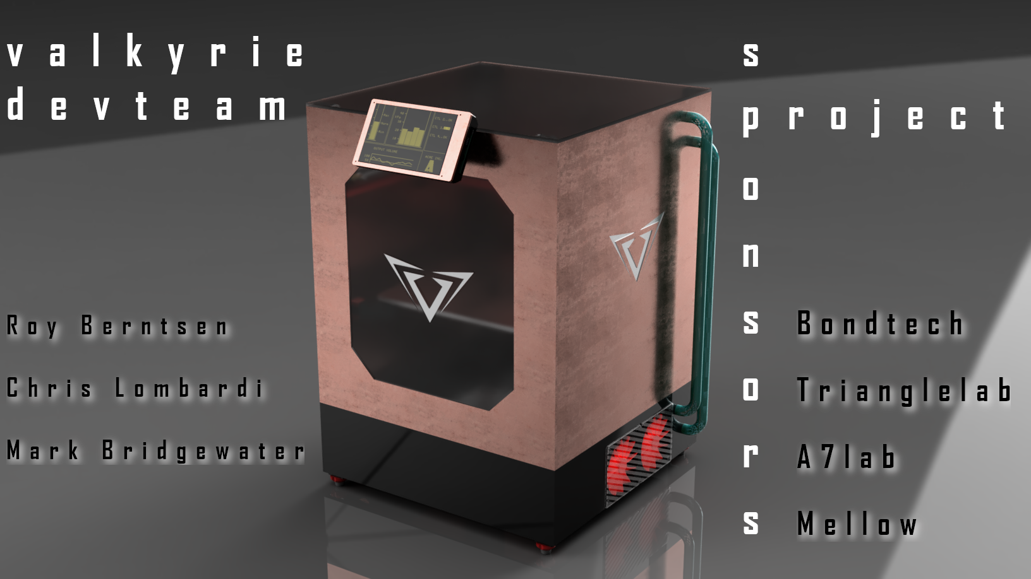

January 2022

# The Development Team

Roy Berntsen - NO

Mark Bridgewater - NZ  
Chris Lombardi - USA

# Material Selection – Enclosure and Drybox Panels

# General Requirements

## Product Choice

* The panels should have high temp rating
* Easily sourced
* Cost effective
* Easy to cut
* Easy to assemble/build
* As thin as possible
* Look good

## Function Choices

* Insulate from chamber temp
* Strong
* Low weight

# Shortlist of Materials

## Enclosure

|  |  |  |  |  |  |
| --- | --- | --- | --- | --- | --- |
| Material | Temp Rating | Durability | Insulator | Comment | **thermal conductivity** W·m−1·K−1). |
| MDF FR | ~130C | Good | good | May need to be sealed , easy to make a box | 0.14 |
| ACM FR ( dibond) | 80C | Good | poor | Great product for outside finish | 0.41 |
| Calcium silicate | 2130C | poor | Excellent | Good as a core product | 0.05 |
| Drywall | 900C | poor | average | Good as a core product | 0.17 |
| Polyisocyanurate Foam Sheets | 149C | Average | V good | Good for a core product needs to be laminated | 0.035 |
| Silicon sheet | 200C | excellent | excellent | Not self-supporting, | 0.24 |
| Poly carbonate | 140C | V good | poor | Warps when heated on one side | 0.22 |
| FR4 G10 | 266C | Excellent | poor | Good as a boundry layer | 1.0 |
| Bakelite | 120C | Excellent | Good |  | 0.2 |
| Industrial Felt | 100C | poor | V Good |  | 0.07 |

## Drybox

|  |  |  |  |
| --- | --- | --- | --- |
| Material | Temp Rating | “Add properies” | Comment |
| MDF |  |  |  |
|  |  |  |  |
|  |  |  |  |

# Material property matrix

## Enclosure (example)

|  |  |  |  |  |  |
| --- | --- | --- | --- | --- | --- |
| **Material properties** | **Heated**  **Dry box Tc** | **Outside Box Tc** | **Watts required** | **Ambient TC** | **notes** |
| 12mm MDF | 90C | 62.9C | 97W | 24C | Smooth inside , to hot on the outside |
| 12mm MDF + 8mm LD Felt | 90 | 38.1C | 38W | 27C | Fluffy inside , outside temperature acceptable |
| 12mm MDF + 9mm calcium silicate |  |  |  |  | Smooth inside |
|  |  |  |  |  |  |
|  |  |  |  |  |  |
|  |  |  |  |  |  |
|  |  |  |  |  |  |

## Drybox (example)

|  |  |  |  |
| --- | --- | --- | --- |
| **Material properties** | **MDF** | **ACM** | **…** |
| Tensile Strength | Medium - low | Medium | Medium |
| Flexible properties | Medium | Good | Very good |
| Impact Strength | High | Good | Very High |
| Cost | Low | Low | Medium-High |
| Impact resistant | High | High | High |
| Cold Climate properties | Good | Good | Good |
| **Material evaluation** | **Medium** | **Good** | **Good** |

# Supplier List